- National accounts revisions suggest the UK economy carried stronger momentum into this year, which is likely to mean we upgrade our 2025 GDP forecast to around 1.5%. But that momentum has faded during the year amid ongoing consumer cautiousness, and we still expect growth in 2026 will be much softer.
- This week, several members of the Bank of England's Monetary Policy Committee shed further light on their assessments of the policymaking landscape. Though Dave Ramsden and Sarah Breedon suggested that further rate cuts are likely, they showed no burning desire to loosen policy at the November meeting as concerns about inflation persistence linger.
Beyond the usual quarterly revisions, this week's Quarterly National Accounts for Q2 also included methodological improvements to be introduced in the annual Blue Book, incorporated more detailed but less timely data sources, and saw the data rebased to 2023 prices from 2022 prices.
Compared with previous Blue Book updates, this year's revisions were relatively small. The key changes were around the quarterly balance of GDP growth during 2024, with Q1 downgraded and modest upgrades to growth across the final three quarters. This meant there was more momentum coming into this year and, with quarterly growth in H1 2025 unchanged, we're likely to raise our forecast for calendar year GDP growth in 2025 by 0.2ppts to 1.5% when we publish an updated forecast next week.
Delving into the detail, the most striking feature of the latest national accounts data was further evidence that consumer cautiousness continues to hold back private demand. Consumer spending rose a measly 0.1% q/q in Q2, having also underwhelmed in Q1. With real household incomes continuing to grow at a decent pace, the household saving ratio rose 0.2ppts to 10.7% in Q2, well above post-global financial crisis norms (Chart 1). With a range of domestic headwinds set to cause real income growth to slow, consumers will need to shed their extreme caution to even sustain the recent sluggish pace of spending growth.
Chart 1: Consumer cautiousness led to a renewed rise in the household saving ratio in Q2
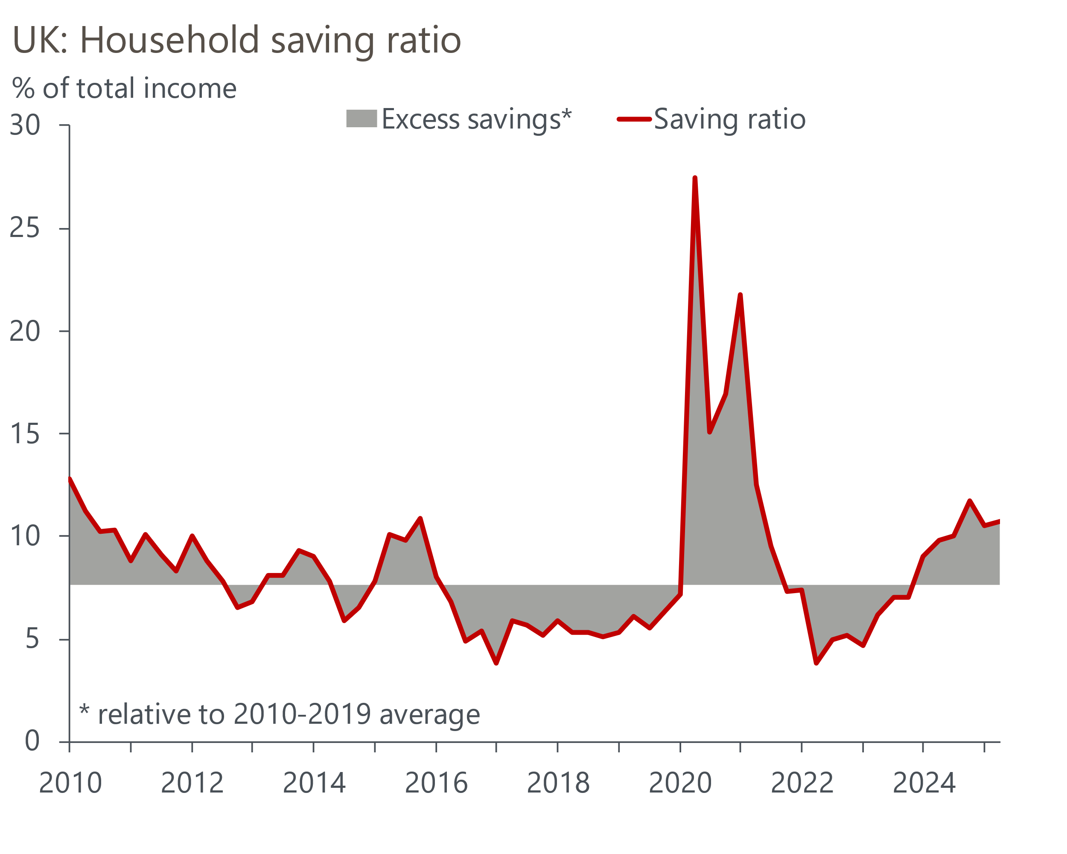
Sources: Oxford Economics, Haver Analytics

The rest of the data also painted a soft picture. A strong rise in government consumption accounted for almost all of the Q2's increase in GDP, following higher spending on vaccines and defence. Meanwhile, investment and net trade dragged on growth during the quarter, as temporary strength from Q1 unwound.
Judging the underlying strength of the economy continues to be complicated by the GDP series showing signs of residual seasonality. Post-revisions, this year's outturns continue to follow the pattern of earlier years, where strong growth in the early months of the year peters out.
Other data also point to sluggish activity. This week's final S&P Global survey for September reported a sharp fall in the composite PMI to 50.1, from 53.5 in August (Chart 2). September's fall was exaggerated by August's unusual strength and fragile business confidence, while the recent relationship between the PMI and GDP is poor. But it's hard to find any data that suggests the pattern of weaker H2's will be broken this year, and we expect the economy to carry weaker momentum into next year than it had at the start of 2025.
Chart 2: The composite PMI sank in September, and points to modest GDP growth in Q3
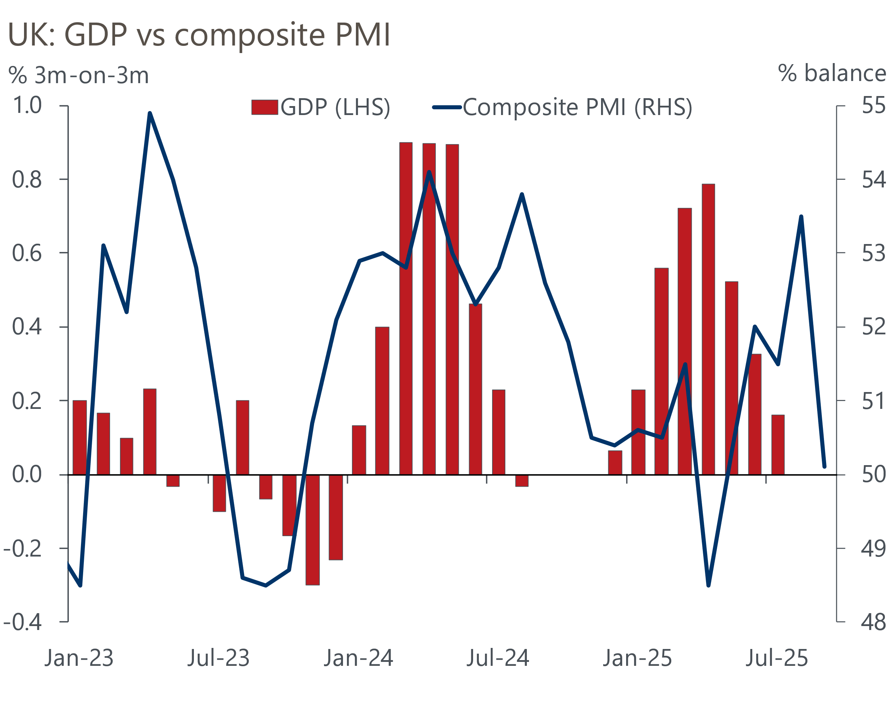
Sources: ONS, S&P Global
The S&P Global survey also reported weaker employment conditions and elevated cost pressures in September, as firms continue to adjust to higher labour costs. But there were some tentative signs that competitive pressures were starting to limit the ability of firms to pass on the cost pressures in the form of higher prices. However, the Bank of England's Decision Maker Panel results for September suggested that firms' expected wage and price growth over the next year remained uncomfortably high.
This makes for a challenging policymaking landscape for the BoE's Monetary Policy Committee. Speaking to the Financial Times earlier this week, external member Catherine Mann argued that households' inflation expectations had drifted away from the BoE's 2% target and that there was a high risk of inflation persisting for longer if Bank Rate isn't held at its current level for a prolonged period.
Mann is one of the more hawkish MPC members. We also heard from two of the group who voted for the most recent rate cut. Though both thought that rates would be cut further, they showed no burning desire to loosen policy in the near term. At a European Central Bank conference this week, Dave Ramsden remarked that he has been surprised by "how long it’s taken for that wage-setting behaviour to come back in line", and was now putting "a bit more weight on the risk" that high food prices lead to second-round effects for inflation.
Sarah Breeden argued in a speech that the recent bump in inflation reflected external shocks and was likely to unwind. But she was also mindful of the risks presented by current high rates of inflation and implied that she isn't strongly minded to vote for a rate cut at the November meeting.
We think most committee members are more worried about lowering Bank Rate too quickly than too slowly, and that the default outcome for the November meeting remains a hold. But we continue to expect rate cuts to resume in the first half of 2026, as the BoE factors in tighter fiscal policy, growth disappoints, and evidence of a sustained cooling in inflationary pressures starts to emerge.

The week ahead
There are no major releases next week.
Table 1: Week ahead calendar
Date | Events | Period | Measure | Unit | Previous | Forecast
Oct 6 | S&P Global construction | Sep | PMI | % bal | 45.5 | 46.0
Oct 7 | Halifax house prices | Sep | m/m | % | 0.3 | 0.4
Oct 7 | Halifax house prices | Sep | y/y | % | 2.2 | 2.5
Source: Oxford Economics

Key forecasts
Table 2: UK forecast overview
(Annual percentage changes unless specified)
 | 2023 | 2024 | 2025 | 2026 | 2027 | 2028
GDP | 0.4 | 1.1 | 1.3 | 0.9 | 1.3 | 1.7
Private consumption | 0.5 | 0.6 | 1.0 | 1.0 | 1.2 | 1.7
Fixed investment | 0.3 | 1.5 | 1.9 | 1.0 | 1.6 | 2.0
Government consumption | 1.6 | 3.0 | 1.8 | 1.8 | 1.6 | 1.7
Exports of goods and services | -0.4 | -1.2 | 2.9 | 0.8 | 1.2 | 1.4
Imports of goods and services | -1.2 | 2.7 | 4.5 | -0.4 | 1.1 | 1.4
Industrial production | -0.8 | -1.2 | 0.3 | -0.3 | 0.8 | 1.2
Consumer prices | 7.3 | 2.5 | 3.5 | 2.9 | 2.5 | 2.1
Unemployment rate (%) | 4.1 | 4.3 | 4.7 | 4.9 | 4.8 | 4.4
Current a/c balance (% of GDP) | -3.5 | -2.7 | -3.3 | -3.0 | -2.8 | -2.7
Government balance (% of GDP) | 5.2 | 5.1 | 4.5 | 3.6 | 2.9 | 2.6
Central bank policy rate (%, EOP) | 5.25 | 4.75 | 4.00 | 3.50 | 3.00 | 2.75
10yr govt. bond yield (%, EOP) | 3.54 | 4.57 | 4.70 | 4.25 | 3.77 | 3.47
Exchange rate (US$ per £, EOP) | 1.27 | 1.25 | 1.33 | 1.34 | 1.34 | 1.34
Exchange rate (euro per £, EOP) | 1.15 | 1.21 | 1.15 | 1.15 | 1.15 | 1.15
Source: Oxford Economics
Table 3: Quarterly forecasts for the UK
 | 2025 |  |  |  | 2026
 | Q1 | Q2 | Q3 | Q4 | Q1 | Q2 | Q3 | Q4
GDP (% year) | 1.3 | 1.2 | 1.3 | 1.4 | 0.9 | 0.8 | 0.9 | 1.0
CPI inflation (% year) | 2.8 | 3.5 | 3.9 | 3.8 | 3.5 | 2.7 | 2.7 | 2.6
Bank Rate (%, EOP) | 4.50 | 4.25 | 4.00 | 4.00 | 3.75 | 3.75 | 3.50 | 3.50
10yr gilt yield (%, EOP) | 4.70 | 4.48 | 4.75 | 4.70 | 4.66 | 4.54 | 4.40 | 4.25
US$ per £ (EOP) | 1.29 | 1.37 | 1.33 | 1.33 | 1.33 | 1.33 | 1.34 | 1.34
Euro per £ (EOP) | 1.20 | 1.17 | 1.15 | 1.15 | 1.15 | 1.15 | 1.15 | 1.15
Source: Oxford Economics

Latest Country Economic Forecast:
September 16, 2025

Recent publications

Data Insights
Services sector vulnerable to the Budget uncertainty
Manufacturing sector remains fragile
GDP growth hides more weakness
The recovery in mortgage demand stumbled in August
PMI confirms sluggish growth outlook

Research Briefings
Fiscal fragility could reveal sterling's vulnerability
MPC follows path of least resistance on quantitative tightening
MPC preview – Pace and shape of QT is likely to be tweaked
What could prompt the BoE to cut further and/or faster?
Stagflation-lite as policy headwinds increase turbulence

Contacts

Oxford Economics' UK team
- Andrew Goodwin - Chief UK Economist - agoodwin@oxfordeconomics.com
- Edward Allenby - Senior UK Economist - eallenby@oxfordeconomics.com

